**ONLINE INSURANCE PROCESSING SYSTEM**

Use case diagram:

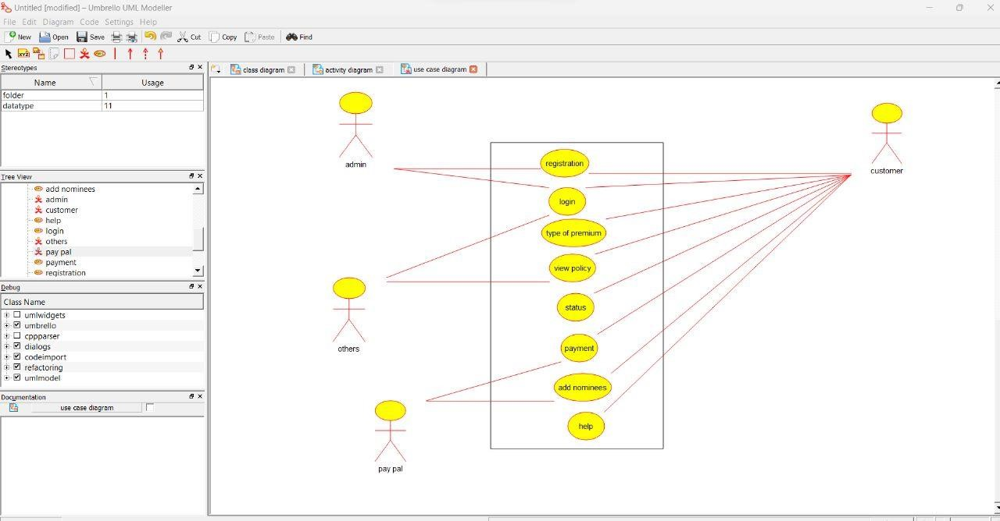

Activity diagram:

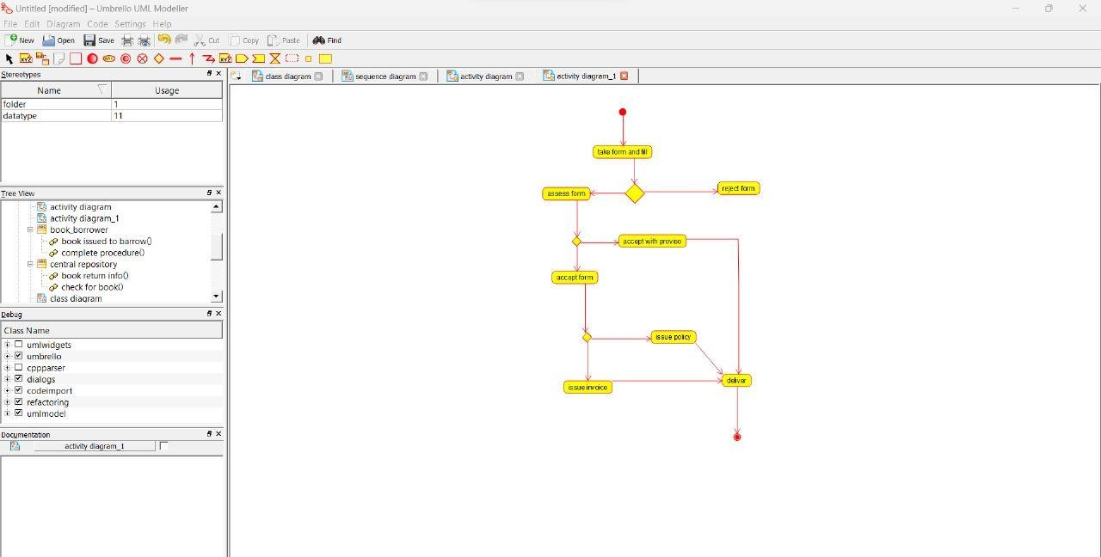

Sequence diagram:

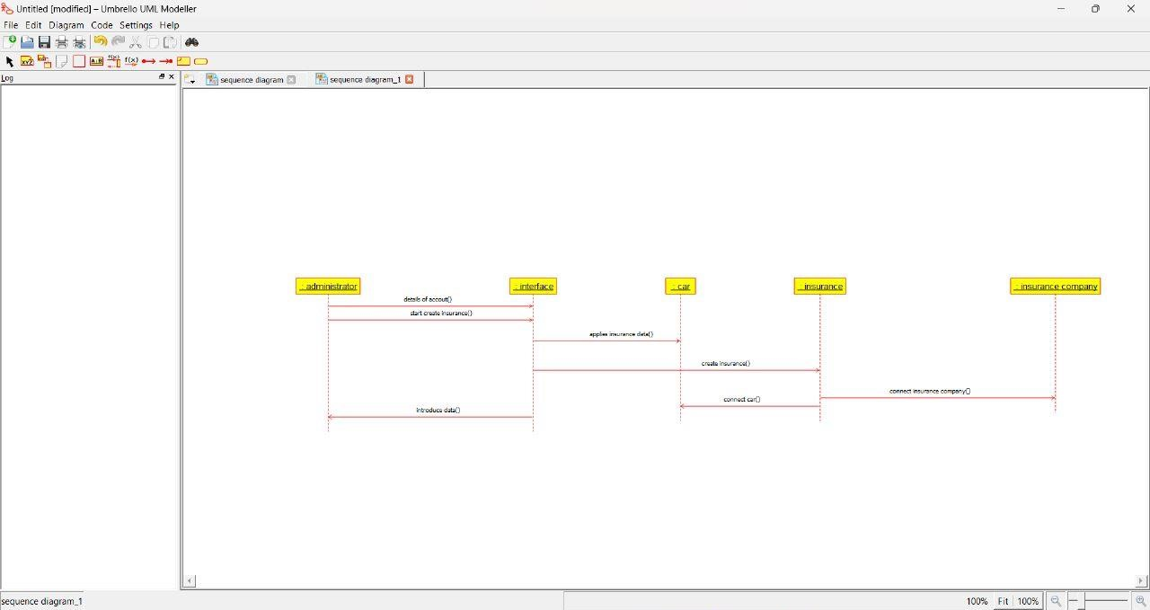

Component diagram:

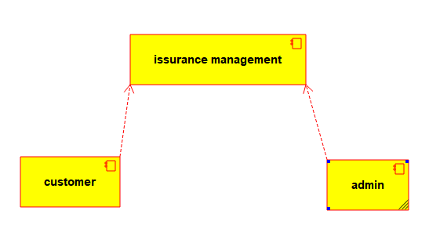

Collaboration diagram: 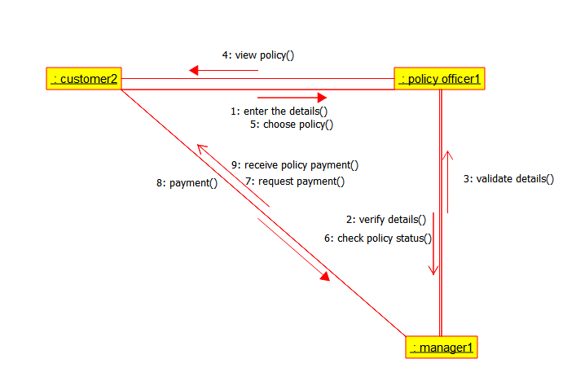

Deployment diagram:

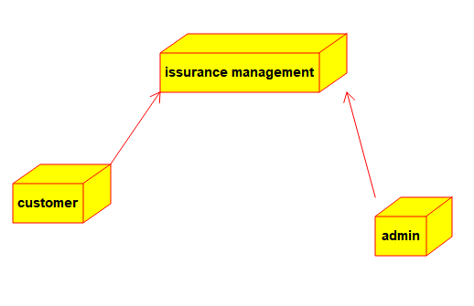

Object diagram:

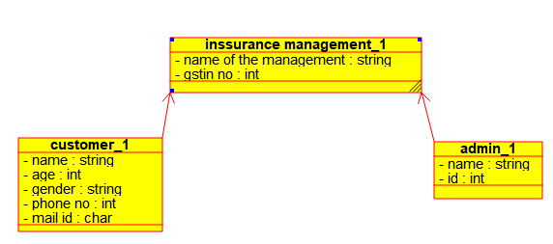

Program:

Insurance management

/**

* Class admin

*/

public class admin {

//

// Fields

//

private String name;

private int id;

//

// Constructors

//

public admin () { };

//

// Methods

//

//

// Accessor methods

//

/**

* Set the value of name

* @param newVar the new value of name

*/

public void setName (String newVar) {

name = newVar;

}

/**

* Get the value of name

* @return the value of name

*/

public String getName () {

return name;

}

/**

* Set the value of id

* @param newVar the new value of id

*/

public void setId (int newVar) {

id = newVar;

}

/**

* Get the value of id

* @return the value of id

*/

public int getId () {

return id;

}

//

// Other methods

//

/**

*/

public void verify_details()

{

}

/**

*/

public void add_new_policy()

{

}

/**

*/

public void remove_or_delete_policy()

{

}

}

/**

* Class inssurance_management

*/

public class inssurance_management {

//

// Fields

//

private String name_of_the_management;

private int gstin_no;

//

// Constructors

//

public inssurance_management () { };

//

// Methods

//

//

// Accessor methods

//

/**

* Set the value of name_of_the_management

* @param newVar the new value of name_of_the_management

*/

public void setName_of_the_management (String newVar) {

name_of_the_management = newVar;

}

/**

* Get the value of name_of_the_management

* @return the value of name_of_the_management

*/

public String getName_of_the_management () {

return name_of_the_management;

}

/**

* Set the value of gstin_no

* @param newVar the new value of gstin_no

*/

public void setGstin_no (int newVar) {

gstin_no = newVar;

}

/**

* Get the value of gstin_no

* @return the value of gstin_no

*/

public int getGstin_no () {

return gstin_no;

}

//

// Other methods

//

/**

*/

public void get_user()

{

}

/**

*/

public void add_policy()

{

}

/**

*/

public void remove_policy()

{

}

/**

*/

public void provide_funds()

{

}

}

Admin:

/**

* Class admin

*/

public class admin {

//

// Fields

//

private String name;

private int id;

//

// Constructors

//

public admin () { };

//

// Methods

//

//

// Accessor methods

//

/**